Write a program to solve a Sudoku puzzle by filling the empty cells.

A sudoku solution must satisfy **all of the following rules**:

1. Each of the digits 1-9 must occur exactly once in each row.
2. Each of the digits 1-9 must occur exactly once in each column.
3. Each of the the digits 1-9 must occur exactly once in each of the 9 3x3 sub-boxes of the grid.

Empty cells are indicated by the character '.'.

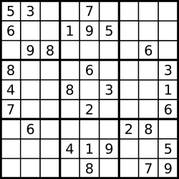  
A sudoku puzzle...

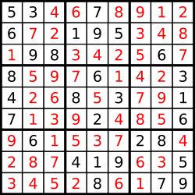  
...and its solution numbers marked in red.

**Note:**

* The given board contain only digits 1-9 and the character '.'.
* You may assume that the given Sudoku puzzle will have a single unique solution.
* The given board size is always 9x9.